Dijkstra Algorithm:

It is a greedy algorithm, used to find mimum distance in weighted graph.(from any node to any other other node).

It uses priority queue.

Source ka distance 0 lete hai.
Children ki distance minimize krte hai.
Visit krte jate hai, aur queue me dalte jate hai..(sare childrens ko..)

Root ko nikal dete hai.
In priorty queue agar pop karneg to minimum distance bahr nikelegi..
Jb bhi koi node queue se bahr nikal rhe hai to , usko process tabhi karenge agar wo visited na ho.... otherwise nhi karenge..

PHIR jo nikalenge dekhege uske sare children ki distance minimize kr skte hai ya nhi...(means calculated dis, previous wale se compare krte hai agar less ho to update kr dete hai...) Jisko minimze nhi kr skte hai usko queue me nhi dalenge...
Intially sbka infinity hota hai...
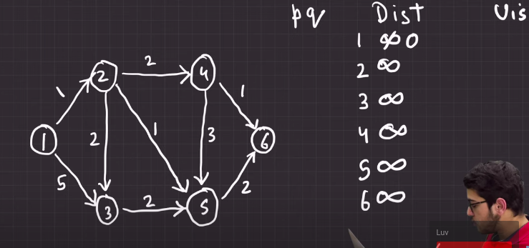
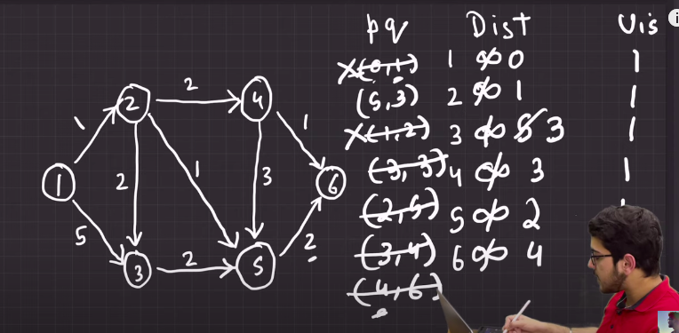
O(n^2) ---> PRIORITY QUEUE USE KARENGE

#include<bits/stdc++.h>
using namespace std;
const int N=1e5+10;
const int INF=1e9+10;

vector<pair<int,int>>g[N]; //node , wt

int dijkstra( int source int n , vector<pair<int,int>>graph[N]){
vector<int>vis(N,0);
vector<int>dist(N,INF);

set<pair<int,int>>st; //wt , node
st.insert({0,source});
dist[source]=0;

//jb tk set khali nhi ho jata
while( st.size()>0){
auto node = *st.begin(); // for first element
int v =node.second;
int v_dist = node.first;
st.erase(st.begin());

if(vis[v]) continue // ek baar bahar nikalene k
//baad phir se andhr nhi dalenge
vis[v]=1;
for( auto child : g[v]){
int child_v = child.first;
int wt = child.second;
if(dist[v] + wt < dist[child_v]){
dist[child_v]= dist[v]+ wt;
st.insert({dist[child_v], child_v});
}
}
}

}

------------------------------------------------------------------------------------------------

IN 2D graph

Example with priority queue

int main(){
int n,m;
cin>>n>>m;
for( int i=0 ;i<m ; i++){
int x,y,wt;
cin>>x>>y>>wt;
g[x].push_back({y,wt});
}

}

class Solution
{
public:
pair<int, int> d[4] = {{0, 1}, {1, 0}, {-1, 0}, {0, -1}};
const int inf = 1e9;
int minimumCostPath(vector<vector<int>>& grid){
int n = grid[0].size();
priority_queue<pair<int, pair<int, int>>, vector<pair<int, pair<int, int>>>, greater<pair<int, pair<int, int>>>> q;

q.push({grid[0][0], {0, 0}});
vector<vector<int>> dist(n, vector<int> (n, inf));
dist[0][0] = grid[0][0];

while(!q.empty()){
int x = q.top().second.first;
int y = q.top().second.second;
q.pop();

for(int i = 0; i < 4; ++i){
int nx = x + d[i].first;
int ny = y + d[i].second;

if(nx < 0 ny < 0 nx >= n || ny >= n){
continue;
}
if(dist[nx][ny] > dist[x][y] + grid[nx][ny]){
dist[nx][ny] = dist[x][y] + grid[nx][ny];
q.push({dist[nx][ny], {nx, ny}});
}
}
}

return dist[n - 1][n - 1];
}
};

Example with set

// { Driver Code Starts
#include<bits/stdc++.h>
using namespace std;

// } Driver Code Ends

class Solution
{
public:
const int INF=1e9+10;
pair<int ,int>d[4]= {{0, 1}, {1, 0}, {-1, 0}, {0, -1}};
//Function to return the minimum cost to react at bottom
//right cell from top left cell.
int minimumCostPath(vector<vector<int>>& grid)
{
int n= grid.size();
vector<vector<int>>dist(n, vector<int>(n,INF));
set<pair<int,pair<int,int>>> st;
dist[0][0]= grid[0][0];
st.insert({grid[0][0],{0,0}}); // start

while(st.size()>0){
auto it = *st.begin();
int wt=it.first;
int x= it.second.first;
int y=it.second.second;
st.erase(st.begin());

for( int i=0 ; i<4 ; i++){
int cur_x=x+d[0].first;
int cur_y=y+d[0].second;
cout<<x<<' '<<y<<' ';
if(cur_x<0 || cur_y<0 || cur_x>=n || cur_y>=n) continue;
cout<<cur_x<<' '<<cur_y<<endl;
if(dist[cur_x][cur_y] > dist[x][y] + grid[cur_x][cur_y]){
dist[cur_x][cur_y]= dist[x][y]+ grid[cur_x][cur_y];
st.insert({dist[cur_x][cur_y],{cur_x,cur_y}});
}

}
}

return dist[n-1][n-1];
}
};

// { Driver Code Starts.
int main(){
int tc;
cin >> tc;
while(tc--){
int n;
cin >> n;
vector<vector<int>>grid(n, vector<int>(n, -1));
for(int i = 0; i < n; i++){
for(int j = 0; j < n; j++){
cin >> grid[i][j];
}
}
Solution obj;
int ans = obj.minimumCostPath(grid);
cout << ans << "\n";
}
return 0;
} // } Driver Code Ends

